IALD Presents Merit Award for Rion Antirion Bridge
Concepto Agency Accepts Award
New York, NY, April 13, 2005 – At its 22nd Annual IALD Awards Presentation, the International Association of Lighting Designers (IALD) is pleased to present an Award of Merit for Rion Antirion Bridge, a bridge located on the Corinth Gulf in Greece, which joins the Peloponnesus to the mainland of Greece. The entry was judged in the monumental structures/public spaces category. This year, 15 projects earned awards of merit, and three of them were in the monumental structures/public spaces category. Principal lighting designers on the project is the lighting designer Roger Narboni. Other designers from the Concepto Agency in Bagneaux, France, include Sara Castagné and Frédérique Parent.
click on thumbnails to
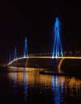 | 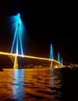 | 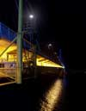 | 
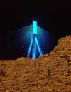 | 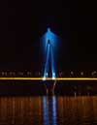 | 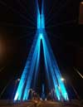 | 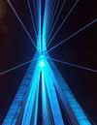 | 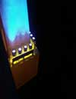
The Rion Antirion Bridge is 27 meters wide and 2300 meters long. It has four towers at intervals across the length of the structure that inspired a design that enhances the nocturnal landscape. The two sides of the gold-painted bridge are illuminated with 560 floodlights equipped with yellow glass filters and visors. Each is positioned to create a horizontal shadow to the next cantilever on the side of the bridge. The towers are illuminated from the bridge floor with 176 floodlights that cast blue highlights which gradually disappear into the dark night sky.
At this year’s 22nd annual event, the IALD awarded 23 projects that represented six of the seven categories. Seven IALD Awards of Excellence were awarded: one in both the corporate and retail/entertainment categories; two in site/façade; and three in the category of monumental structures/public spaces. Fifteen projects earned IALD Awards of Merit, two in both the hospitality and corporate categories; three in the site/façade category; and four in each of the retail/entertainment and monumental structures/public spaces categories. The highest point earner wins the Radiance Award for Excellence in Architectural Lighting Design. An IALD Special Citation for innovative use of materials and techniques for daylighting control was granted for an entry in the academic/institutional category.
The IALD Lighting Design Awards program, established in 1983 and co-sponsored by Professional Lighting Design magazine, honors lighting projects that display high aesthetic achievement backed by technical expertise. Entries are submitted into one of seven categories: Academic/Institutional; Corporate; Hospitality; Monumental Structures/Public Spaces; Residential; Retail/Entertainment; and Site/Façade. Additionally, projects can also be submitted for consideration in the sustainable design award category, which means the project undergoes an additional round of judging keyed solely to the fulfillment of sustainable design principles. A panel of award-winning lighting designers and architects review the projects.
This year, the IALD received 141 submissions from 14 countries. The IALD, established in 1969, is an international organization dedicated to the profession of architectural lighting design. Based in Chicago and comprised of 700 members throughout North and South America, Europe, Asia and Australia, the IALD’s role is to set the global standard for lighting design excellence.
Additional information can be downloaded from www.IALD.org.

